A000-Afr- Equatorial Guinea-Fang-Ntumu-early 20th c

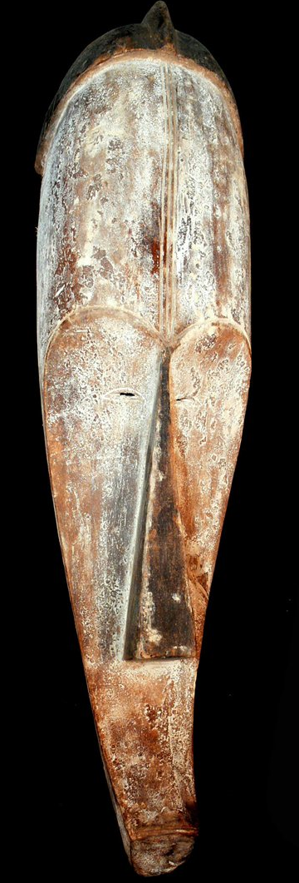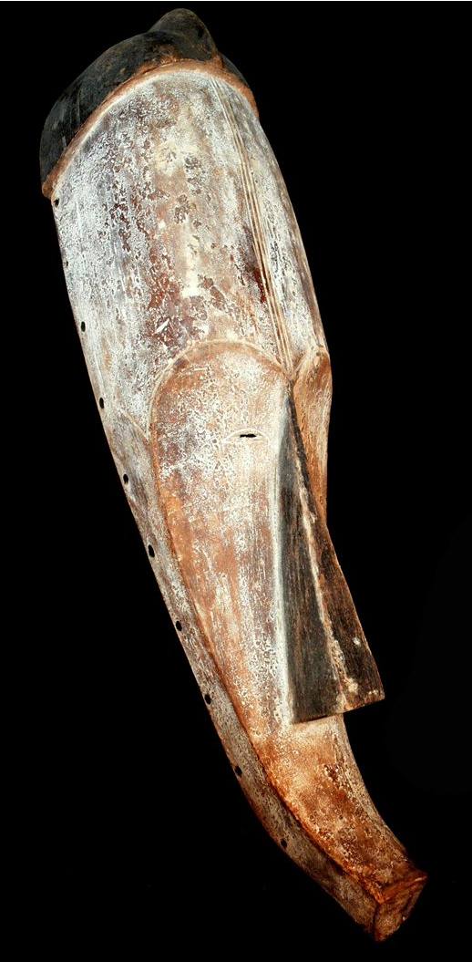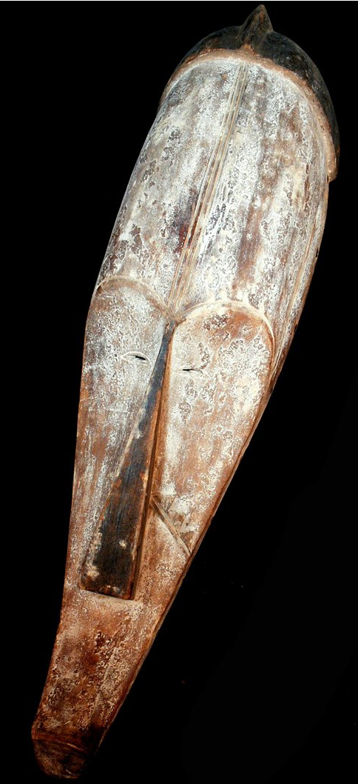

Case No.: 6

**Accession No.**

**Formal Label:** Afr- Equatorial Guinea-Fang-Ntumu-early 20th c

**Display Description:**

Northern Continental Equatorial Guinea, Ntumu Fang Dance Mask. This mask belongs to the Ntumu speaking group in the Ebebiyin area of northern continental Equatorial Guinea. The mask is similar to the Ngil masks of the nineteenth century Fang traditions and is probably dated to ca. 1940. It must be a variation of the ekekek which were prouced in the Wolen-Ntem basin in Gabon and were used for celebration dances on feast days, initiation ceremonies and for family celebrations of death mourning, and birth. The flat, concave face and prognathous mouth and black painted hair (which was a fashion that had its vogue shortly after World War II all contribute to its provenance (Perrois 1990: 160-161).

The mask is worn by a man whose upper body is covered with raffia fibers and animal skins that are attached to a neck collar. The Ntumu mask is worn during daytime rituals, when dance is performed in the courtyard of the village. At the time of the dance, the wearer is possessed since the Ntumu represents a spirit from the world of the dead, from beyond the seas, the land of the whites, that is, those of the spirit world. The diversity of faces corresponds to the variety of clairvoyant spirits represented.

**LC Classification:**

**Date or Time Horizon:**

**Geographical Area:**

**Map:**

**GPS coordinates:**

**Cultural Affiliation:**

**Media:** soft wood, white kaolin and polychromatic finish

**Dimensions:** 25.984 inches high

**Weight:** 1.51 pounds,

**Condition:**

**Provenance:**

**Discussion:**

**References:**

Perrois, Louis, Delage, Marta Sierra. 1990. *The art of Equatorial Guinea: the Fang tribes*. New York: Rizzoli.